Reception’s Enrichment Grid – Autumn 1
Number Investigations  How many plates do you need for dinner for the family?  How many knives and forks do I need to put in the dishwasher?  How many cups of tea do my family drink during the day? | Reading  Go to the library and chose some books to share with your grown up – these could be books about starting school or stories about families  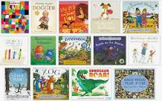 | Understanding the World  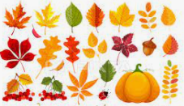  Go on a walk with a grown up and look for things to collect, acorns /conkers / fern cones / twigs / leaves. When you get home you could sort them into groups (by object, size). What do you notice? How are they different/similar? | Understanding the World  Use your objects from your walk to create some transient artwork  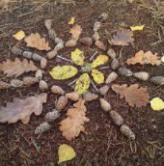
Challenge  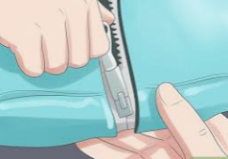  Learn to put on and take off your coat on your own. As an extra challenge you could learn to do your own zip too!  Can you put your socks and shoes on? | Reading and Writing  Once we start, practise reading and writing the letters we have learnt in RWI – get creative – you could use chalk on the driveway or patio, use a paintbrush and water on a fence/shed/wall  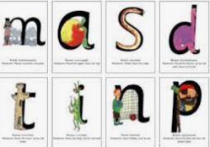 | Understanding the World  Talk about how you can keep yourself healthy – hand washing, the foods we eat, keeping ourselves clean, how we can look after our teeth  What jobs can I do at home to help? How do we look after our house? Can I put my toys away?  Can I help my family make dinner? (with supervision) | Understanding the World    Join in with some Cosmic Kids Yoga (please ensure an adult is supervising)

