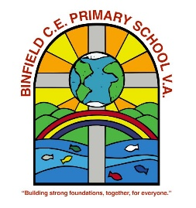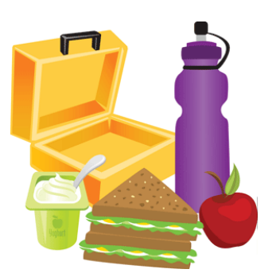
Packed Lunch Policy
Introduction
As you are aware, good food is important for the health and well-being of our children. At Binfield Primary School, we feel it is important to support the children in making healthy life-style choices. We therefore use many opportunities in school to achieve this, such as through the PSHCE, science and PE curriculum, the Cool School Cafe and extra-curricular activities. Following the successful incorporation of healthy meals within the Cool School Cafe, we would like to encourage the children having packed lunches to make similar nutritious choices.
Following advice from the School Food Trust and after consultation with parents, pupils, staff, governors and the school Catering Manager, we have produced a Packed Lunch Policy.
The aim of this policy is to provide advice and support to parents in providing healthy and nutritious packed lunches.
Food and drink in packed lunches
Ideally, your child’s packed lunch should include:
- at least two portions of fruit/vegetables every day;
- a source of protein, e.g. cheese, lentils, kidney beans, hummus, chickpeas, meat, eggs or falafel every day;
- oily fish, such as salmon, at least once every three weeks if possible;
- a starchy food, such as bread, pasta, rice, couscous, noodles, potatoes or other types of cereal every day;
- dairy food, such as milk, cheese, yogurt, fromage frais or custard every day;
- only water, pure fruit juice, semi-skimmed or skimmed milk, yogurt or milk drinks and smoothies.
Packed lunches may include ONE of the following on Fridays only:
- Snacks such as crisps - on other days, alternatives to crisps could include seeds, vegetables or fruit (with no added salt, sugar or fat). Savoury crackers or breadsticks served with fruit, vegetables or dairy food are a good choice.

or
- Chocolate-coated biscuits or cakes - cakes and plain biscuits are acceptable occasionally as part of a balanced meal.
or
- Meat products, such as sausage rolls, individual pies, corned beef and sausages/chipolatas
Plates: If your child is eating a packed lunch, please provide a small plastic plate for them to eat from. This is to encourage good manners and hygiene. Please make sure their lunch box and plate is clearly named.
Special Diets and Allergies
The school recognises that some pupils may require special diets that do not allow for the standards to be met exactly. In this case, parents are encouraged to be responsible for ensuring that packed lunches are as healthy as possible. For these reasons, pupils are not permitted to swap food items.
Please note: Nuts and nut spreads (e.g. peanut butter, Nutella, etc.), are not permitted as they may cause serious health problems to those children who have severe food allergies.
Snacks at break time
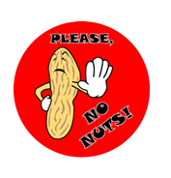We are a nut free school. Children should not bring anything containing nuts to school. We have children and adults who suffer from a severe allergic reaction which, if they come into contact with nuts, could be fatal.
Children may, if they wish, bring fruit and/or vegetables for a mid-morning snack, however sweets, cakes, biscuits, cereal bars and crisps are not allowed. For the children in Year R, drinks are available throughout the day, water is provided by the school. A free snack (e.g. apple, satsuma, pear, banana or carrot) is provided by the government for morning playtimes for children in YR, Year 1 and 2.
Please ensure your child brings a named water bottle (of 300ml-500ml size) into school. Please can we ask for no Stanley style cups/bottles to be used in school.
Evaluation and review
As this policy is envisaged as a partnership between parent and school, we value parents’ support and cooperation. If it becomes apparent that children’s lunchboxes do not conform to this advice, the school will contact parents to discuss this.
This policy is reviewed annually. Last Reviewed/Updated: September 2025

