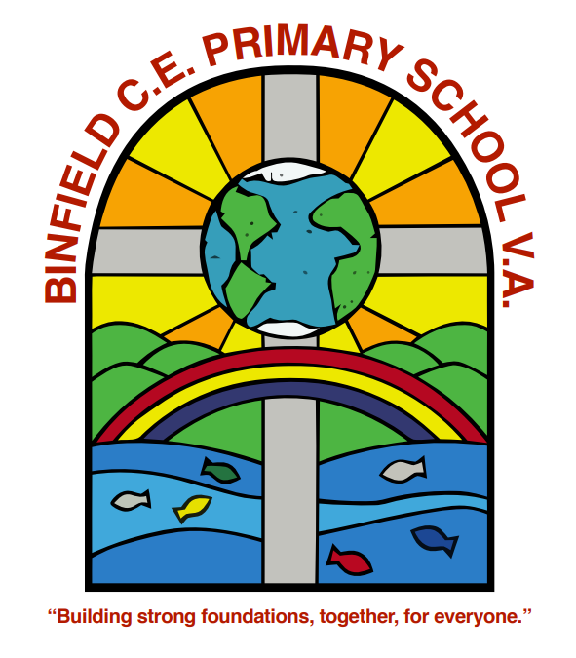

Spiritual Development Policy

May 2024
Review date: May 2026

Spiritual Development Policy

What is spirituality? Our definition.
At Binfield CE Primary School (VA), ‘Spirituality is the way in which we combine our thoughts and emotions to reflect, respond to, and seek to give meaning and purpose to the experiences that we encounter in life’.

The windows, mirrors, doors analogy clarifies this meaning.
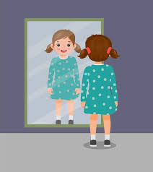

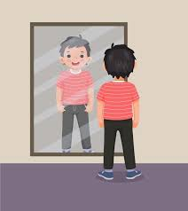

We gaze out through windows onto the world, responding with our emotions and trying to make sense of what we see. We use mirrors to reflect on our thoughts and feelings, and how what we see through the window connects with our inner selves, and how we connect with what we see and understand. This becomes a spiritual experience when it transforms us and so we walk out through the door into life differently from before. For some, this spiritual experience leads to a sense of transcendence: in other words, a feeling or belief that something exists beyond what can be directly seen. Christians would describe this state as God.
How do we see spiritual development in others and in pupils?
Pupils’ and others’ spiritual development is shown through their:
- Beliefs, religious or otherwise, which inform their perspective on life and their interest in and respect for different people’s feelings and values
- Sense of enjoyment and fascination in learning about themselves, others and the world around them, including the intangible
- Use of imagination and creativity in their learning
- Willingness to reflect on their experiences
There are many aspects to spiritual development, such as:
Beliefs – The development of personal beliefs, including religious beliefs; an appreciation that people have individual and shared beliefs on which they base their lives; a developing understanding of how beliefs contribute to personal identity

A sense of Awe and Wonder - ‘Wow and Ow moments’ – being inspired by the natural world, mystery, or human achievement or the realisation that humans don’t always have a positive impact in the world.
Experiencing feelings of transcendence – Feelings which may give rise to belief in the existence of a divine being, or the belief that one’s inner resources provide the ability to rise above everyday experience
Search for Meaning and Purpose – Asking ‘why me?’ at times of hardship or suffering; reflecting on the origins and purpose of life; responding to challenging experiences of life such as beauty, suffering and death.
Self-Knowledge – An awareness of oneself in terms of thoughts, feelings, emotions, responsibilities and experiences; a growing understanding and acceptance of individual identity; the development of self-respect.

Relationships – Recognising and valuing the worth of each individual; developing a sense of community; the ability to build up relationships with others.

Creativity – Expressing innermost thoughts and feelings; exercising the imagination, inspiration, intuition and insight.

Feelings and Emotions – The sense of being moved by beauty or kindness; hurt by injustice or aggression; a growing awareness of when it is important to control emotions and feelings and how to learn to use feelings as a source of growth.

Steps to Spiritual Development
Applying the insights gained with increasing degrees of perception to one’s own life
Developing personal views and insights

Understanding and evaluating a range of possible responses and interpretations
Questioning and exploring the meaning of experience

Becoming aware of and reflecting on experience
Recognising the existence of others as independent from oneself

Effective learning in itself is a spiritual experience. This is because learning involves engagement with and exploration of a new concept [windows], thinking deeply about it, trying to connect it to what we already know [mirrors]. If we can successfully fit this new concept to our pre-existing web of understanding, this evokes a positive emotional response [we often describe this as: the penny drops!]. With each new concept acquired, we transform ourselves [doors], moving forward in life a little altered, intrinsically motivated, fulfilled and inspired by the experience.

Why is spiritual development important?
As a church school, our vision is to educate the ‘whole person’ and the spiritual growth of our children is as important as, and indeed is as vital a contributor to their academic and wider development. The themes developed each week through our assemblies, as well as opportunities woven throughout our curriculum underpin all we seek to achieve in the lives of our children. Getting people to consider the world around them, reflecting and thinking for themselves, evoking positive emotional responses and pondering ultimate questions is the integral ingredient in our recipe for spiritual development.

How is provision made for spiritual development?
Because spiritual development is a key standout feature of what makes us distinctive as a church school, the provision of opportunities for spiritual development can be thoughtful, deliberate and intentional or can just happen.
Our Ethos created by our vision and values in practice, supports the provision made for spiritual development to take place. We are about, ‘Building strong foundations, together, for everyone.’ As such, Spiritual development is an integral part of our school curriculum and daily life.

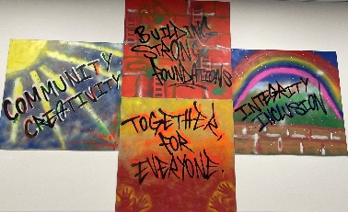
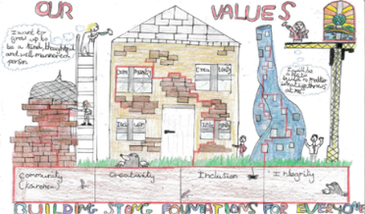
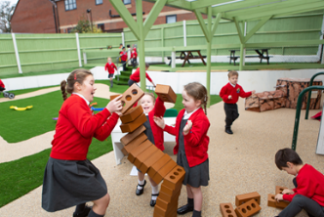
‘Building strong foundations, together, for everyone.’

…to work together as a school community to build strong foundations needed for our children to become well-rounded, responsible global citizens and lifelong learners. We focus on the development of the ‘whole person’ and provide a safe, caring community, underpinned by Christian values in order to achieve this.
Reference: Matthew 7:24-27; Luke 6: 46-49 “My words said Jesus are like that rock. And if you build your life on them, then you will stand firm too. Firm like the house on
The importance of Collective Worship and RE in supporting spiritual development.

Collective worship and RE are two key areas of school life that provide ideal vehicles for effective spiritual development.
Collective Worship provides opportunities for:
- Reflection and response
- Thinking deeply and drawing links between ideas
- Stillness and prayer
- The respect of personal and collective beliefs
- Sharing and celebrating common beliefs
- Celebrating success and talent
- Sharing happiness, sorrow, hurt, excitement, anticipation, fear, etc.
- Shared activities such as singing, listening, laughing, reflecting on a theme
- Remembering and celebrating the lives of people of spiritual significance
- Emphasising common purpose and values
- Experiencing emotions
- Taking part with sincerity and a sense of higher purpose
- Through pupil-led worship, children have the opportunity to support the spiritual development of others, that in turn leads to a sense of fulfillment and is therefore a spiritual experience for the young leaders
- Creative responses to experiences such as music, drama, poetry, story
- The use of visual stimulus such as religious symbols, candles, art, icons, photos, video

Religious Education is an academic subject that looks at the spiritual experiences of others and how these change and shape their lives. RE allows children to use what they find out about other people and their beliefs to reflect on their own experiences. Through this process, children can engage with ultimate questions of meaning and purpose and begin to shape their own beliefs. RE allows children to engage with the idea of mystery and questions with no clear answers.

Spiritual Development in the wider curriculum

The wider curriculum also provides opportunities for spiritual development.

At Binfield, we develop our Thinking Skills known as our ‘Power Tools for Learning’.
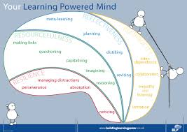
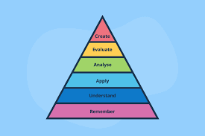
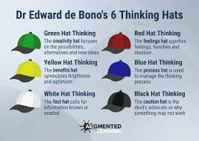
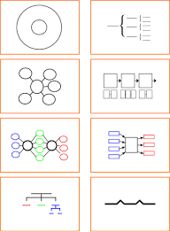

These support us to think deeply, ask questions, make links, solve problems and reflect on things, even on our own thinking! These are used across the whole of the curriculum and support with spiritual development.
In Physical Education:
- Being a team member.
- Pushing yourself to the limits.
- Extremes of skill, endurance and achievement.
- Emotion in sport such as those evoked through success and failure
- Personal limitation and acceptance that others may perform better
- Appreciation of perfection.
- Being a good sport.
In Design and Technology:
- Discovering how something works.
- Appreciating ingenuity.
- Beauty in design.
- Perseverance to solve problems.
- Personal achievement.
- Learning from others and nature.
In English:
- Empathy with authors and the characters in stories and plays.
- The appreciation of beauty in language.
- Emotions and sentiments in writing and speech.
- The values of great works.
- Heroes and heroines in literature.
- The reading and writing of poetry.
- Imagining oneself as someone else.
- Escaping into other worlds through literature.
- The element of wonder in literature.
- Pleasure derived from the creative process.
In Maths:
- Infinity and nothing.
- Pattern and order.
- Shape and regularity.
- Truth, certainty and likelihood.
- The universality of mathematics over time and space.
- The wonder of numbers, formulae and equations.
In Science:
- Wonder as the basis of science.
- Questions of beginning, creation and evolution.
- Discovering the limits of experimentation.
- Birth, life, death and renewal.
- The universe and beyond.
- Regularity and order in science.
- Beliefs in science and the faith of scientists.
- The impact of scientific achievements.
In Computing:
- The wonder of worldwide instant communication.
- The speed of the growth of knowledge.
- The accessibility of knowledge and contact with other people worldwide.
- The ability to write their own program and fix bugs
- The range of new technology that is enhancing learning and helping people’s lives e.g. bionic arms; robots; AI.

In the Creative Arts (Art, Music, Drama and Dance):
- The work of creative artists from a variety of times and places.
- Beauty, truth and goodness.
- Expressing, interpreting and exploring deep feelings and profound beliefs.
- Artistic creativity.
- The effects of the arts on emotions and senses.
- The arts as means of expressing mood.
- Skill in creation and performance, and particularly in personal reflection upon their own creativity using various art forms.
- Effects on the emotions and senses.
- Personal response and preference.
- Mood.
- Skill.
- Pattern.
- Formulae.
- The sense of fulfillment and transcendence through performance.
In Geography:
- Wonder at the diversity of environments and people.
- Questions about the care of the environment.
- The beliefs behind particular causes and campaigns.
- World (economic) development.
- Land formation.
- Empathy with people from other parts of the world.
In History:
- Being in touch with past people, things and ideas.
- Being part of history.
- Handling artefacts.
- Influential events and people.
- The commitment of significant people in history.
- War and peace.
- Interpretation in history.
- The nature and importance of invention and exploration.
- Empathy with people from other times in history.
- Being outraged by some of the events in history and asking why?

Evaluating Spiritual Development
We do not believe that Spiritual development is something that should be or even can be ‘measured’. It grows in each person in different ways, at different rates, at different times and is uniquely personal. When evaluating spiritual development in our school, we take a more holistic approach and consider how spirituality is supporting our vision to be lived out in practise in helping our pupils become ‘….well-rounded, global citizens and lifelong learners’. This feeds into the school processes for continued improvement and development.

