To build and overview of world history.
C: Mayan Cities and Temples.
Introduction:

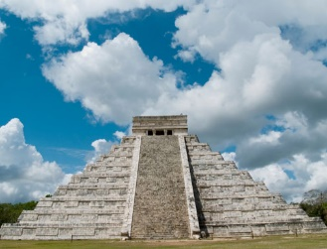 Chichén Itzá

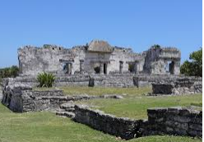 Tulum

RP: Which temple would you like to visit and why?

