Binfield C.E. Primary School (VA)



School Admissions Arrangements

2025/2026

Date Produced / Signed off: March 2024

Next Review Date: March 2025

Status: Final

Binfield C of E Primary School (VA) is a voluntary aided school. As such, the Governing Body is the admissions authority for the school. The school is a partner in the coordinated admissions arrangements for primary admissions in Bracknell Forest LA. All the dates and processes of application and consideration will conform to the Bracknell Forest LA’s Coordinated Admissions Scheme, which will be published when finalised and will then be common to all schools within the LA.

Our Vision:
Building strong foundations together, for everyone…..

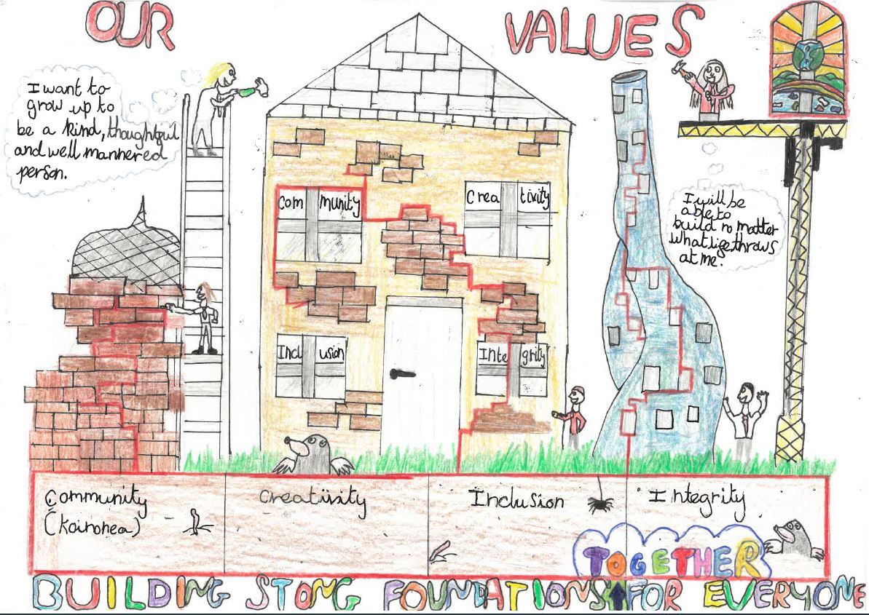

…to work together as a school community to build strong foundations needed for our children to become well-rounded, responsible global citizens and lifelong learners. We focus on the development of the ‘whole person’ and provide a safe, caring community, underpinned by Christian values in order to achieve this.

Admissions Process:
In line with the Planned Admission Number (PAN) of sixty, the Governing Body of Binfield C of E Primary School (VA) will admit up to sixty children in the school year 2025/2026.

Children who become five years of age on or between 1st September 2025 and 31st August 2026 will be eligible to be considered for admission. It is intended that places will be offered for entry in September 2025. Parents of a child whose fifth birthday falls between 1 September 2020 and 31 March 2021 may request that their child is not admitted until later in the school year 2025/26 (no later than the term [using three term year] after the child’s fifth birthday, when s/he reaches compulsory school age). The school will hold any deferred place for the child, although, in the majority of cases, we find that children benefit from starting at the beginning of the school year, rather than part way through it.

For children whose fifth birthday falls between 1 April 2021 and 31 August 2021 (summer-born children), parents who do not wish them to start school in school year 2025/26, but to be admitted to the Reception Year in September 2026, should proceed as follows:

- They should apply at the usual time for a place in September 2025, together with a written request that the child is admitted outside his or her normal age group to the Reception year in September 2026. NB: parents would need to provide strong supporting reasons for seeking a place outside the normal age group and should discuss the position with the head teacher as early as possible.

- If their request is agreed, and this should be clear before the national offer day, their application for the normal age group may be withdrawn before any place is offered and they should reapply in the normal way (no later than 15 January 2025) for a Reception place in September 2025.

- If their request is refused, the parents must decide whether to wait for any offer of a place in September 2025 (NB it will still be subject to the over-subscription criteria below) or to withdraw their application and apply in the second half of the summer term 2026 for a Year 1 place in September 2026.

- Parents should be aware that the Year 1 group may have no vacancies, as it could be full with children transferring from the 2025/26 Reception Year group.

It is the governors’ policy not to reconsider applications within the same academic year unless there is a major change in circumstances. If the child’s needs are considered profound the school would wish to offer only a part time place until the child’s needs have been properly assessed and the appropriate provision put in place.

Until the child reaches compulsory school age, parents may also request that s/he attends part-time.
In such cases, detailed arrangements should be discussed with the head teacher.

Applications for a place at the school should be made on the Common Application Form (CAF) provided by the Bracknell Forest LA. If applying from outside Bracknell Forest applications should be made using the CAF of the home LA. The CAF must be completed and returned to the LA by 15th January 2025.

The Bracknell Forest LA’s address is: School Admissions Team, Time Square, Market Street, Bracknell
RG12 1JD

As an alternative to completing the paper Common Application Form (CAF), parents will be able to apply for a primary place online via their home LA’s website. The Bracknell Forest Council site will be open for applications for first entry to school in 2025/26 from mid October 2025 to (midday on) 15th January 2026.

Applicants will still have to send in a paper copy of their current council tax statement, in order to prove their residency.

This documentary evidence will then be matched to their on-line application.

The Bracknell Forest LA will collate the information and send copies of that information to the school for consideration by the Governing Body.

The Governing Body of Binfield C of E Primary School (VA) will consider first those applications that are received by the published admission deadline. All applications will be considered equally, irrespective of ability or stated preference.

Over subscription criteria
Children with a statement of Special Educational Needs or with an Education, Health and Care (EHC) Plan naming the school will always be admitted.

If the number of applications exceeds the number of places (PAN = 60), the following criteria will then apply, in order of priority:

- Looked-after children and children who were previously looked after, but ceased to be so because, immediately after being looked after, they became subject to an adoption, child arrangements or special guardianship order. This includes those children who appear (to the admission authority) to have been in state care outside of England and ceased to be in state care as a result of adoption. Applications under this criterion must be accompanied by evidence to show that the child is looked after or was previously looked after (e.g. a copy of the adoption, child arrangements or special guardianship order) (See Note 1).

- Families who have exceptional medical or social needs (see Note 2) that make it essential that their child attends Binfield Church of England Primary School rather than any other. These needs must be fully supported by written evidence from the appropriate professional person involved with the family.

- Children whose parents are members of staff (see Note 3).

- Children with a sibling (see Note 4) on the roll of the school at the time of application or whose parent has accepted an offer of a place at the school and who is expected still to be in attendance at the time of entry to the school.

- Children with a normal home address (see Note 5) in the designated area detailed on the map held by Bracknell Forest LA, Binfield C of E Primary School (VA) School Office and Bracknell Public Library (this is the designated area, as in previous years). [Appendix 1].

- All other children whose parents (see Note 6) have chosen this school.
If the school does not have places for all the children in one of the above categories, priority will be given to children who fulfil more than one of the admission criteria in the same priority order as above.

This means that those that satisfy criteria 2, 3 and 4, for example, will be considered before those that satisfy criteria 2 and 3, who will be considered before those that satisfy criteria 2 and 4, who will be considered before those who satisfy criterion 2 only. Another example is that those who satisfy criteria 3 and 4 will be considered before those who satisfy criterion 3 only, who will be considered before those who satisfy criterion 4 only.

After this, if there are still insufficient places and no distinction can be made between the applicants, a final decision will be made on the radial distance between the home and the school.

Those living nearer to the school will be placed higher than those living further away. Radial distance will be based on the co-ordinates for the property and the school – known as the ‘C’ point, as defined in the Local Land and property Gazetteer and based on the Ordnance Survey’s national system.

Distances are measured using direct distance calculations within a computer system. The measurement of each distance has been calculated using Pythagoras’ Theorem. The way in which this is done is to calculate the distance in metres between the Easting and Northing co-ordinates for each location. The measurement in metres is then multiplied by 0.000621317 to convert this measurement to miles. The same method of calculation is used for each distance measured.

When two or more children applying are equally placed according to the criteria and radial distance from the school as measured by the LA, then lots will be drawn, and the first name drawn will be placed highest in order of priority and so on.

Drawing of Lots
The names of the applicants will be written on equal size and shape pieces of paper that will be folded into four and placed in a paper bag. A person independent of the school will draw one paper at a time from the bag.

If the demand for places exceeds the PAN, the school will admit up to the Planned Admission Number and no places will be reserved for pupils moving into the designated area.

The Governing Body will make its decision about the allocation of places based on the above order of criteria, and will submit (a) a ranked list of all applications to the LA by 13th March 2025 and (b) an explanation of how places have been allocated so that this may be sent out to unsuccessful applicants.

The Bracknell Forest LA and the Governing Body will construct a waiting list (from the above information) and agree on who should be contacted if a place becomes available.

Notes:

Note 1:
- By a “looked-after child” we mean a child who is (a) in the care of a local authority, or (b) being provided with accommodation by a local authority in the exercise of their social services functions (see the definition in Section 22(1) of the Children Act 1989) at the time of making an application to a school. A child is regarded as having been in state care outside of England if they were in the care of or were accommodated by a public authority, a religious organisation, or any other provider of care whose sole or main purpose is to benefit society.
- An adoption order is one made under the Adoption Act 1976 (Section 12) or the Adoption and Children Act 2002 (Section 46).
- A ‘child arrangements order’ is one settling the arrangements to be made as to the person with whom the child is to live (Children Act 1989, Section 8, as amended by the Children and Families Act 2014, Section 14).
- A ‘special guardianship order’ is one appointing one or more individuals to be a child’s special guardian/s (Children Act 1989, Section 14A).

Note 2:
- Families who have exceptional medical or social needs:
When applying under criterion 2 (exceptional medical or social needs), you must include supporting evidence from an independent professional person who is aware of the situation and supports your reasons for preferring Binfield Primary School. This supporting evidence must clearly demonstrate why the school is the most suitable and must illustrate the difficulties that would be caused if your child had to attend another school. The person supplying the evidence should be a doctor, heath visitor, social worker, etc. who is aware of your child’s or your own case. The school reserves the right to ask for further evidence or clarification where necessary and may seek the advice of appropriate educational professionals where necessary.
(Taken directly from ODBE Admission Guidance 2022/2023)

Note 3:
- Members of staff are those staff who:
  - a) are employed permanently and directly by the Governing Body and have been for at least two years at the time the application is made, or
  - b) staff employed for 15 hours or more a week by contractors appointed by the Governing Body and work solely on the school site, for at least two years or
  - c) any member of staff recruited to fill a vacancy for which there is a demonstrable skills shortage or where there has been significant difficulty in filling the post through the usual recruitment method.

Note 4:
“A sibling” refers to brother or sister, half-brother or half-sister, step brother or step sister, or the child of parent/carer’s partner where the child for whom the school place is sought is living in the same family unit at the same address as that sibling.

Note 5:
“Home address” is the address at which the child and parent resides for the majority of each week.

Note 6:
“Parent” is defined in law (The Education Act 1996) as either:
- any person who has ‘parental responsibility’ (defined in the Children Act 1989) for the child or young person; or
- any person who has care of the child or young person.

If you are in any doubt, please contact the school for advice.

Exceptional Circumstances – Multiple Births
In cases where there is one place available, and the next child on the list is a twin, triplet etc., we would admit both twins (and all children in the case of other multiple births) even if this meant exceeding the agreed admission number of 60 for the Reception Classes 2025-26 or the number of places (60) in other year groups.

Admission Outside Normal Age group
Requests for places outside a normal age group will be considered carefully e.g. for those who have missed education due to ill health. Each case will be considered on its own merits and circumstances. However, such admissions will not normally be agreed without a consensus that to do so would be in the pupil’s interests. It is recommended that parents discuss their wishes with the headteacher in advance of applying for a place. The governors may ask relevant professionals for their opinion on the case. It should be noted that if a place in the requested age group is refused, but one in the normal age group is offered, then there is no right of appeal.

Late Applications
Applications in the main entry round for places in Reception received after the specified closing date will be dealt with in line with the Bracknell Forest Primary Co-ordinated Admissions Timetable.

In Year Admissions
The Governing Body of Binfield C of E Primary School (VA), is a party to the ‘In Year Fair Access Protocols’ of Bracknell Forest Council. This covers, for example, children who have moved into our area after the normal admission round, or who need to move school as a result of severe bullying or social issues. Children qualifying under the Fair Access Protocol may be offered a place even if there are no places available in the relevant school year group and also take priority for admission over any child on the waiting list.

Applications from children moving into the area or wishing to transfer between schools will be assessed against all criteria in this policy, in the same way as with applications for initial admission. If the parent or carer is moving into the area, they should ask for an application form from Binfield CE Primary School. The forms should be returned to Binfield CE Primary School. In KS2 classes only, the governing board have agreed to exceed the PAN of 60, up to a maximum of 64 per year group i.e. 32 per class. This is to support the demand for places in KS2 and to support the school’s financial situation in mitigating lower birth rates/excess of school places in the borough in infant classes. If the year group is fully subscribed the applicant, who cannot be offered a place, will be placed on the waiting list in the position that their application warrants. (The criteria above will be used and the radial distance as measured by the Bracknell Forest LA will be used to distinguish between otherwise equal applications).

The governors have made every effort to ensure that these arrangements comply with the School Admissions Code 2012 and all relevant legislation, including that on infant class sizes and equal opportunities.

Waiting List
A waiting list is constructed for each year group in the school that is oversubscribed. The order on each waiting list will be constructed in accordance with the above criteria with radial distance and/or lots used to decide between otherwise equal applications. Waiting lists are managed by the LA on behalf of the Governors. The only part of the process conducted by the Governors is to indicate to the Local Authority the criteria the prospective pupil fulfils.
(Existing wording)

The school maintains waiting lists for those children who are not offered a place. Parents who wish for their child’s name to be added to the waiting list need to request the waiting list option if completing an In-Year application form from Binfield CE Primary School. The order of priority on the waiting list is the same as the list of criteria for over-subscription, and does not depend on the date on which an application is received. No account is taken of length of time on a waiting list, however, parents must reapply at the beginning of July if they wish to remain on the wait list for the next academic year.
(Adapted from page 12 of ODBE Admissions Guidance)

Further information on the school’s admissions arrangements may be obtained by contacting the Headteacher at the school:

Binfield C of E Primary School (VA)
Benetfeld Road
Binfield
Bracknell
Berkshire RG42 4EW

Tel: 01344 860106

Email: secretary@binfieldschool.com

Further information about the Co-ordinated admissions scheme is available from the LA at

Bracknell Forest School Admissions Team
Time Square
Market Street
Bracknell RG12 1JD

In the year 2019/20, 124 applications were received for children to enter foundation and they were placed in the following categories***:

Category | Number of Applicants | Ranking number
1 | 0
2 | 1 | 1
3 & 4 | 14 | 2-15
3 only | 30 | 16-45
4 only | 7 | 46-52
5 only | 72 | 53-124
Late Applications | 0
There were no appeals

Note: The categories above relate to:
Looked after child, 2) Staff child/ren, 3) Designated area, 4) siblings, 5) all other children whose parents have chosen this school.

In the year 2020/21, 116 applications were received for children to enter foundation and they were placed in the following categories:

Category | Number of Applicants | Ranking number
1 | 0 | 0
2 | 0 | 0
3 & 4 | 9 | 1-9
3 only | 37 | 10-46
4 only | 8 | 47-54
5 only | 62 | 55-116
Late Applications | 0
There were no appeals

Note: The categories above relate to:
Looked after child, 2) Staff child/ren, 3) Designated area, 4) siblings, 5) all other children whose parents have chosen this school.

In the year 2021/22, 91 applications were received for children to enter foundation and they were placed in the following categories:

Category | Number of Applicants | Ranking number
1 | 1 | 1
2 | 0 | 0
3 & 4 | 20 | 2-21
3 only | 20 | 22-41
4 only | 4 | 42-46
5 only | 46 | 47-81
Late Applications | 0
There were no appeals

Note: The categories above relate to:
Looked after child, 2) Staff child/ren, 3) Designated area, 4) siblings, 5) all other children whose parents have chosen this school.

In the year 2022/23, 98 applications were received for children to enter foundation and they were placed in the following categories:
Category | Applicant | Rank
1&2 | 0 | 0
3 Only | 0 | 0
4&5 | 15 | 1 - 15
4 Only | 11 | 16 - 27
5 Only | 25 | 28 - 53
6 | 47 | 54 - 98
Late Applications | 0

There were no appeals.

Note: The categories above relate to: 1) Looked after child, 2) Medical Needs, 3) Staff Children, 4) Siblings, 5) Designated area, 6) all other children whose parents have chosen this school.

In the year 2023/24, 136 applications were received for children to enter foundation and they were placed in the following categories:

Category | Number of Applicants | Ranking Number
1 | 0 | 0
2 | 1 | 1
3 | 0 | 0
4&5 | 24 | 2 - 25
4 only | 5 | 26 - 30
5 only | 46 | 31 - 77
6 only | 58 | 78 - 136
Late Applicants | 0

There were no appeals.

Note: The categories above relate to:
1) Looked after child, 2) Medical Needs, 3) Staff Children, 4) Siblings, 5) Designated area, 6) all other children whose parents have chosen this school.

Right of Appeal
In accordance with the 1998 School Standards and Framework Act, parents whose children are refused admission have the right of appeal. The appeal will be heard by an independent panel.

Appeals should be made in writing on the appropriate form, which can be obtained from the school secretary, and returned within the timescale in the letter from the home LA or Governing Body refusing admission.

Completed forms should be sent (in an envelope marked ‘Appeal’) to:

The Chair of Governors.
Binfield C of E Primary School (VA)
Benetfeld Road
Binfield
Bracknell
Berkshire RG42 4EW
Appendix 1 – Catchment Map (a larger resolution map is available on request – secretary@binfieldschool.com)


