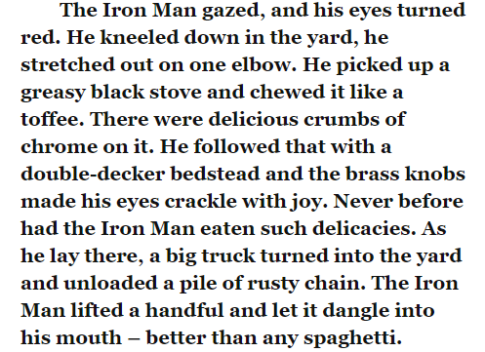
Task
Having finished the chapter, I want you think about how the Iron Man is feeling.
How do the Iron Man’s feelings and emotions change from the beginning of the chapter to the end?


