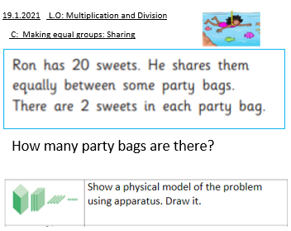
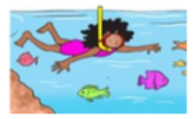
19.1.2021 L.O: Multiplication and Division
C: Making equal groups: Sharing
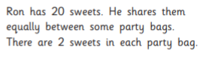
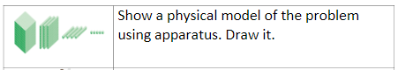
How many party bags are there?

