Meeting Minutes 27th January 2026

- Attendees & Introductions

Nicola Jenkins
Jessica Simpson
Emma Turner
Steve Roby
Karen Hardy
Ali Melabie
Victoria Lunn
John Sutton
Keely Galloway

- Co-Chair update

- The Chair extended sincere thanks to all parents, carers and volunteers and supporters for their incredible efforts in December.
- Over £7,000 was raised through December’s fundraising activities.
- Appreciation was given to everyone who contributed their time, donations and energy to make the events such a success.
- The level of community support and engagement was recognised as outstanding.
- Funds raised will directly support initiatives and enhancements for the benefit of the school and pupils.
- Focus on 2026 summer term will be education of parents in the younger year groups for them to have a better understanding of what we do and defining events and easy fundraisers.

- Teacher update

Budgets are tighter than ever and what Fobs provide is amazing so thank you for what you do! Funding requests are as follows: Coaches PGL and Ufton £2,020 (this has already been approved) we need to double check this has been allocated for next year.
A £1000 for the pool. In future we would want changing rooms for the swimming pool to make things easier for the children changing. Therefore this cost could increase.
Mr Leavens would like £200 for DT week as part of enrichment week for materials for making puppets.
£285 for Light box and white board
£150 for a new lost property box
£490 for the copy write material play script
£830 for the fencing around the adventure trail

Total £4,980

- Finance
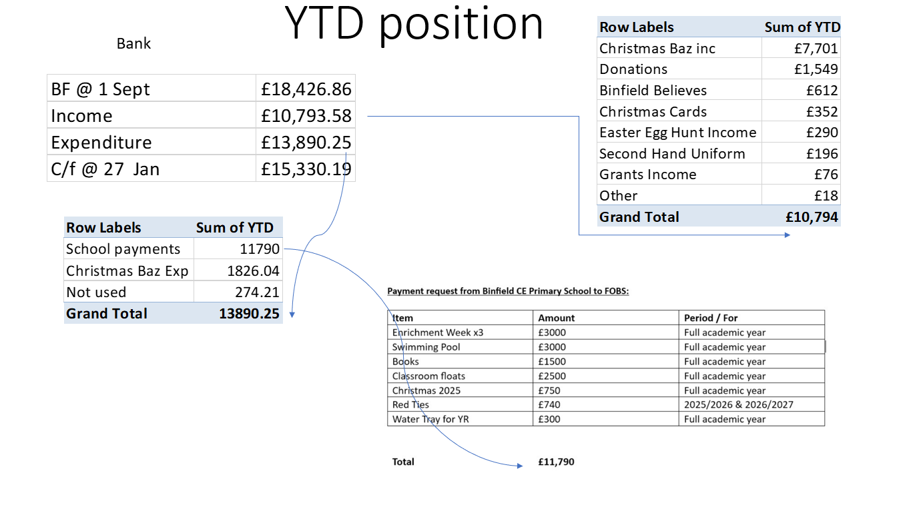

- Claire’s award

This award is being launched by the school with Fobs for all pupils in the school to be given out in July and a letter will be going out to the parents about this and Jess will be giving a power point to the children about this. Jess is involved because Claire was her sister-in-law and because Jess also does all the comms so wanted to do this.

- Voting

Item | Votes
Ring fencing money for Claire’s award | Ali, Victoria, Jess, Steve, Keeley, Karen, Nic
For the funding requests from teachers as a whole lot | Ali, Victoria, Jess, Steve, Keeley, Karen, Nic

- AOB
We need to put a date in for uniform sales and need 4 people to help with this and could do with 4 people to help sort out the shed. Agreed on 6th March for next uniform sale. Nic to empty black uniform box in office reception so its empty for more donations.

Events summary

Uniform sale – 6th March
Little recyclers – 10th March
Easter Egg hunt – April break
Legoland tickets – 13th April
Summer event – 28th June – details TBC

Next meeting is the 24th February 2026

