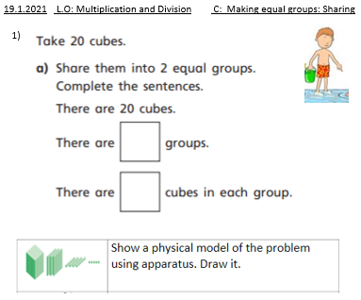
19.1.2021 L.O: Multiplication and Division C: Making equal groups: Sharing
1)



