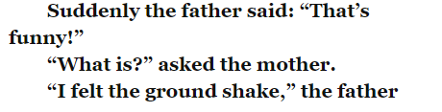
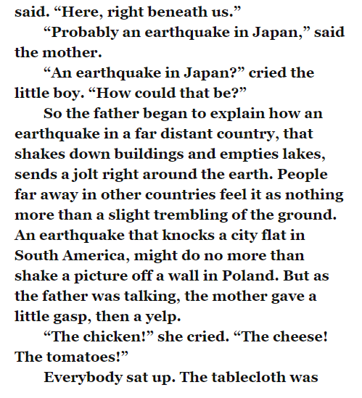
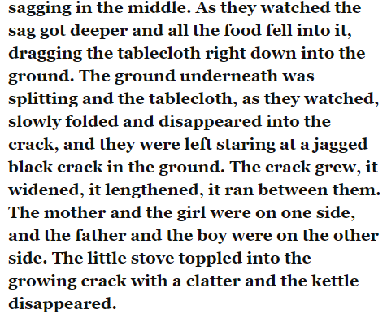
Task
Read the text and answer the question below in full sentences before reading on.
- What do you think has caused the ground to tremble? Why?
- What do you think is going to happen to the kettle and stove which fell through the crack?
Now read the next section.

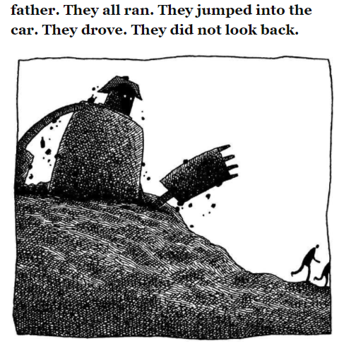
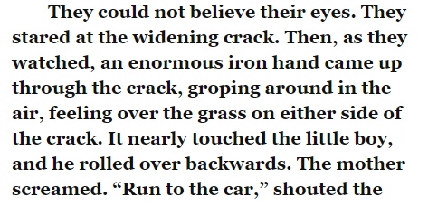
Task
3) How do you think the family are feeling? Use evidence from the text to justify your answers.

