Reception’s Enrichment Grid – Autumn 1
Please chose one or two activities a week to do at home with your child. Please upload photos to Evidence Me!
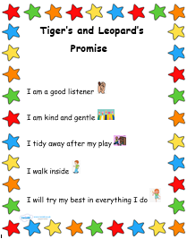 | Go to the library and chose some books to share with your grown up – these could be books about starting school or stories about families  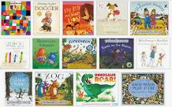 | 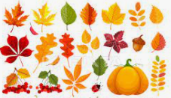  Go on a walk with a grown up and look for things to collect, acorns /conkers / fern cones / twigs / leaves. When you get home you could sort them into groups (by object, size). What do you notice? How are they different/similar? | Use your objects from your walk to create some transient artwork  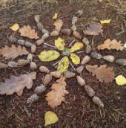
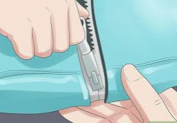  Challenge  Learn to put on and take off your coat on your own. As an extra challenge you could learn to do your own zip too! | Once we start, practise reading and writing the letters we have learnt in RWI – get creative – you could use chalk on the driveway or patio, use a paintbrush and water on a fence/shed/wall  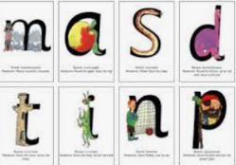 | Keep us Healthy  Talk about how you can keep yourself healthy – hand washing, the foods we eat, keeping ourselves clean, how we can look after our teeth   |   Join in with some Cosmic Kids Yoga (please ensure an adult is supervising)

