Reception’s Enrichment Grid – Summer 1
Please chose one or two activities a week to do at home with your child. Upload any photos of your completed activities on to Evidence Me!

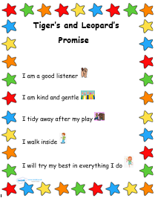  Continue to talk about rules and how you could achieve these at home and in school! | Bog Baby  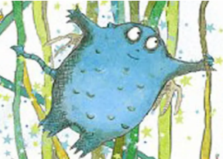  You now have your Bog Babies at home, can you make a home for then in your garden.  Why not take a walk to see some blue bells in the woods? | Number hunt  Go for a walk with your grown up, what numbers do you recognise?  Look at front doors, car number plates, road signs etc  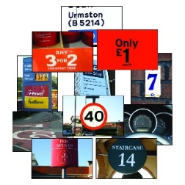Can you tell me 1 more/less than the number you have found? | Letter formation  Please look at the rhymes for each letter and practise forming them correctly! You could write a letter to a family member or friend!  You will find the Rhymes on the link below - https://binfield-church-of-england-primary-school.secure-primarysite.net/letter-formation-2/  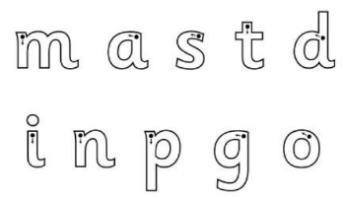
Making 10  Using objects around the house can you find different ways to make ten?  - There are tens frames and part whole frames on our class page to use to show your findings, or maybe you could display them in a different way?  https://binfield-church-of-england-primary-school.secure-primarysite.net/maths-resources-1/ | Using cutlery  The children have been trying really hard this year to use a knife and fork at lunch times. Please reinforce this at home during your mealtimes. For fun, you could practise with playdough  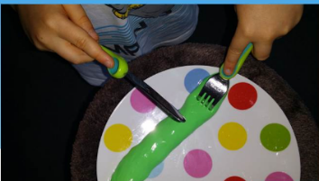 | Zips and buttons  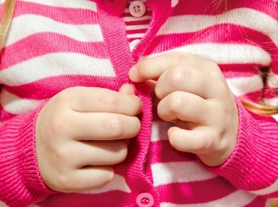  Please continue to encourage your children to dress/undress independently, specifically doing their zips and buttons! | Caterpillars  Our caterpillars arrived this week (16th April). Ask your child to tell you about how they change each week. You could keep your own dairy at home!  

