Reception’s Enrichment Grid – Autumn 2
Please chose one or two activities a week to do at home with your child.
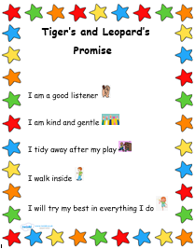 | Fireworks    Did you see any fireworks? What did they sound/look like? Did you like/dislike them? Can you tell your grown up all about them? | Nursery Rhyme Week  13th-19th November  What nursery rhymes do you know? Could you perform them with actions? Maybe you could make up your own actions.  The link below has lots of well-known nursery rhymes as well as new ones.  https://www.bbc.co.uk/teach/school-radio/nursery-rhymes-songs-medleys/zf2792p | Nativity    Practise your lines for our Nativity.  (These will be handed out within the first few weeks of term)
Independence  Dressing and undressing  Please continue to use lots of encouragement and practise with dressing and undressing – including taking shoes and socks off.  Practise getting your coat on, and doing the zip up. There is a video on the class page to show you a top tip for encouraging the children to do this independently. | Celebrations  What celebrations do you have with your family? How do you celebrate?    Please share any celebrations you have with your family using Evidence Me. | Fine Motor  Please refer to the Fine Motor letter that was sent out before half term – try and do at least one activity a day.  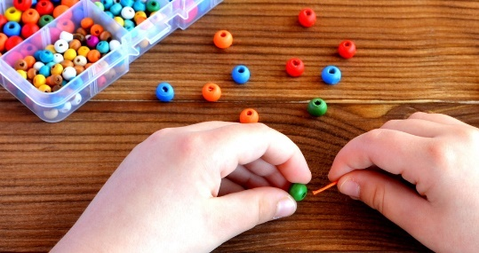 | Anti-Bullying Week  1^{t3h} – 17th November  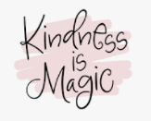  We would like to spread kindness through this week, using the grid below, pick a few acts of kindness to spread a little happiness this week!

Random Acts of Kindness Grid



