Reception’s Enrichment Grid – Spring 1
Please chose one or two activities a week to do at home with your child. We love seeing what the children are doing at home, so please upload any work to Evidence Me, thank you!
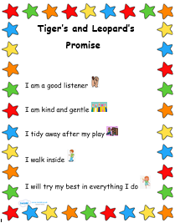  Continue to talk about rules and how you could achieve these at home and in school! | The World Around Us  Look at and talk about the weather every day. You could start a tally chart to see which is the most type of weather we have this term.  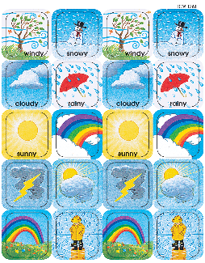 | Caring about the World Around Us  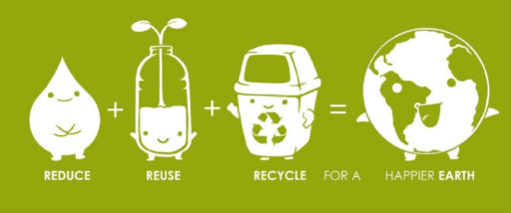  What changes could we make to look after our local environment? Recycling, planting seeds /trees /vegetables etc. Could you make some changes at home? Remember to turn the lights off, recycle your plastic, paper and card. | Where do we live in the world?  Use google earth to search for your house and discuss where you live in the world. You can use street view to have a look at your street.  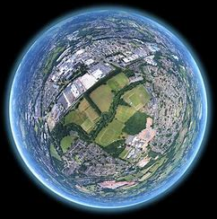
Random Act of Kindness  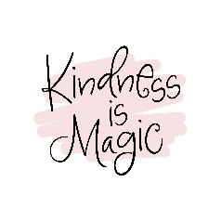  Can you think of a something you could do for a relative, friend or neighbour to put a smile on their face? | Lunar New Year  We will be looking at and celebrating Chinese New Year. There are a few videos on CBeebies to watch and talk about with your child.  Chinese and Lunar New Year - CBeebies - BBC   | Cooking/Baking  Encourage your child to help measuring ingredients while cooking or baking. Talk to your children about how much of each ingredient they need. Below is a simple playdough recipe that you could try and make with your child.  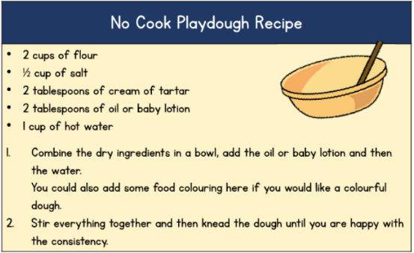 | Challenge  During the year we encourage the children to think about dressing themselves appropriately for the weather we are experiencing. Please work with your child to do their own zips up on their coats, put their own gloves and hats on.  Thank you for your cooperation with this!

