 Wb: 30.11.20 Bubble 11 (1BC) 12 (1LS)
 | 8:30  9:20 | 9:20-10:20 | 10:20-10:30 | 10:30-11:20 | 11:20-11:35 | 11:35-12:10 | 12:10 | 12:30-1 | 1-1:20 | 1:20-2 | 2-2:30 | 2:40-3:20  Home
Mon | Handwriting | RWI  https://www.youtube.com/watch?v=yln6PpV1G1I  Purple or Pink Level RWI  http://tiny.cc/d310tz | Break | Maths –  Count forwards and backwards and write numbers to 20 in numerals and words  https://vimeo.com/480768128 | Break | English  Read the story of Jack and the beanstalk. Answer comprehension questions about the story. Predict what will happen next. Can you come up with your own questions about the story? | Assembly | Lunch | Break | Games | Games | Reading
Tues | Handwriting | RWI  https://www.youtube.com/watch?v=yln6PpV1G1I  Purple or Pink Level RWI  http://tiny.cc/d310tz | Break | Maths –  Numbers from 11 to 20  https://vimeo.com/480769444  . | Break | English  Use the picture cards to order the story of Jack and the beanstalk. Orally retell the story. Try to use expression. | Assembly | Lunch | Break | Maths Minute  https://www.topmarks.co.uk/addition/robot-addition  Story | BOLE | Reading
Weds | Handwriting | RWI  https://www.youtube.com/watch?v=yln6PpV1G1I  Purple or Pink Level RWI  http://tiny.cc/d310tz | Break | Maths – Tens and ones (first part of sheet)  https://vimeo.com/480324356 | Break | Seaside –  Go on a walk outside and make a list of the human and physical features. Once home, compare this to the human and physical features of the seaside. What’s the same and what’s different?  Write some sentences about Binfield and the seaside e.g. I like Binfield because the park is fun. At the seaside, I can play with the sand. | Assembly | Lunch | Break | Maths Minute  https://www.topmarks.co.uk/addition/robot-addition  Story | BOLE  Can you spot any human and physical features outside? | Reading
Thurs | Handwriting | RWI  https://www.youtube.com/watch?v=yln6PpV1G1I  Purple or Pink Level RWI  http://tiny.cc/d310tz | Break | Maths – Tens and ones (second part of sheet)  https://vimeo.com/480325207 | Break | RE  Read or watch the Nativity story.  What questions do you think the shepherds might have asked Mary and Joseph about baby Jesus?  Write the questions you come up with on the sheet provided on our class pages. | Assembly | Lunch | Break | Maths Minute  https://www.topmarks.co.uk/addition/robot-addition  Story | BOLE | Reading
Fri | Handwriting | RWI  https://www.youtube.com/watch?v=yln6PpV1G1I  Purple or Pink Level RWI  http://tiny.cc/d310tz | Break | Maths – Count one more and one less  https://vimeo.com/480325729 | Break | Art –Christmas art  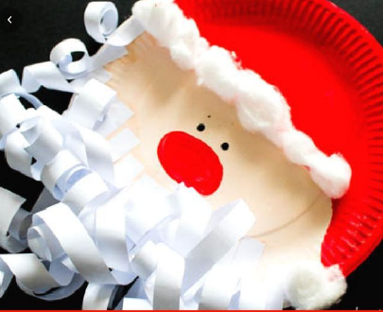 | POW | Lunch | Break | Maths Minute  https://www.topmarks.co.uk/addition/robot-addition  PSHE  What makes a good friend?  Write or draw one way that you are a good friend on the friendship token. | BOLE | Reading

