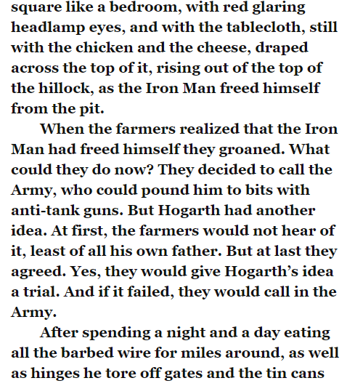
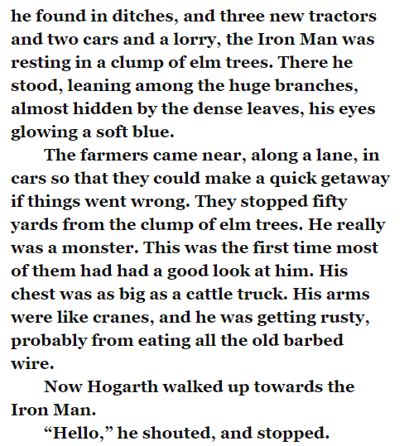
Read the text above and then think about what you think Hogarth’s plan is. Write a paragraph explaining what you think Hogarth’s plan is and why.

