Snorkelling

Sound
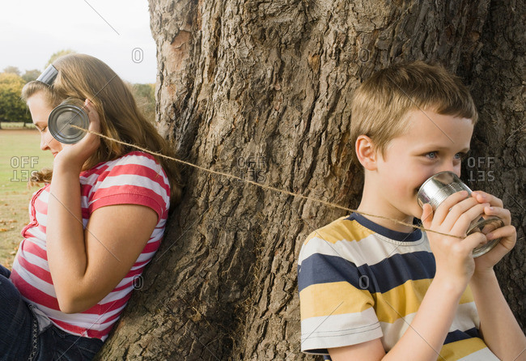
Travels
Vibration
Vibrates
Move
Taut
Loose
Soft
Material
Absorb
Solid

