 Wb: 30.11.20 Bubble 11 (1BC) 12 (1LS)
 | 8:30  9:20 | 9:20-10:20 | 10:20-10:30 | 10:30-11:20 | 11:20-11:35 | 11:35-12:10 | 12:10 | 12:30-1 | 1-1:20 | 1:20-2 | 2-2:30 | 2:40-3:20  Home
Mon | Handwriting | RWI  https://www.youtube.com/watch?v=yln6PpV1G1I  Green or Orange Level RWI  http://tiny.cc/d310tz | Break | Maths – Compare groups of objects  https://vimeo.com/483168827 | Break | English  Read the story of Jack and the Beanstalk again. Turn the story into a story map. Here is an example 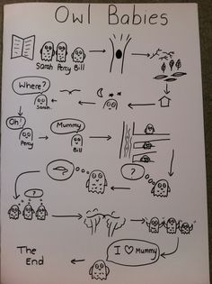 | Assembly | Lunch | Break | Games | Games | Reading
Tues | Handwriting | RWI  https://www.youtube.com/watch?v=yln6PpV1G1I  Green or Orange Level RWI  http://tiny.cc/d310tz | Break | Maths – Compare numbers  https://vimeo.com/483169674  . | Break | English  Write the story of Jack and the Beanstalk. Focus on capital letters, full stops and finger spaces. Use your story map from yesterday to help you. | Assembly | Lunch | Break | Maths Minute  https://www.topmarks.co.uk/addition/robot-addition  Story | BOLE | Reading
Weds | Handwriting | RWI  https://www.youtube.com/watch?v=yln6PpV1G1I  Green or Orange Level RWI  http://tiny.cc/d310tz | Break | Maths – Order groups of objects  https://vimeo.com/483537557 | Break | Seaside – How could we find out about seaside holidays in the past? What would you like to know?  Watch Magic Grandad P1 https://www.youtube.com/watch?v=zWgnpY4L9so  Sort the pictures into past and present. | Assembly | Lunch | Break | Maths Minute  https://www.topmarks.co.uk/addition/robot-addition  Story | BOLE  Can you spot any human and physical features outside? | Reading
Thurs | Handwriting | RWI  https://www.youtube.com/watch?v=yln6PpV1G1I  Green or Orange Level RWI  http://tiny.cc/d310tz | Break | Maths – Order numbers  https://vimeo.com/483539572 | Break | RE  Read or watch the nativity story  The Birth of Jesus Christ | Christmas Story for Kids | Animated Children's Bible Stories Holy Tales - YouTube  Use your imagining learning muscle.  What questions do you think the shepherds would ask Mary and Joseph about the baby Jesus?  Write your ideas on the sheet provided  (See Class Pages) | Assembly | Lunch | Break | Maths Minute  https://www.topmarks.co.uk/addition/robot-addition  Story | BOLE | Reading
Fri | Handwriting | RWI  https://www.youtube.com/watch?v=yln6PpV1G1I  Green or Orange Level RWI  http://tiny.cc/d310tz | Break | Maths – Review  Pick 3 number cards and put them in order from smallest to largest.  Pick 2 number cards and use the correct symbol between them ≤≥ =  Pick a number from 11-19 and show using tens and ones or with counters on a tens frame | Break | Art –Christmas art  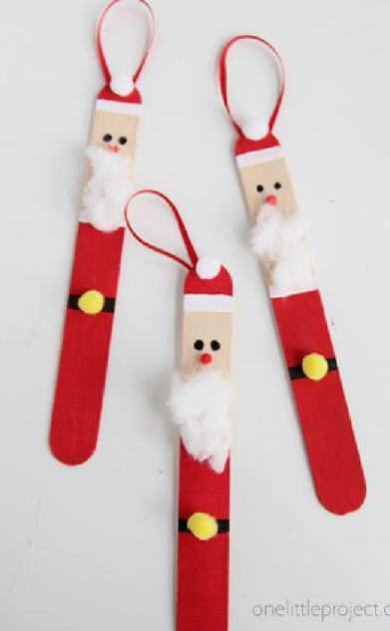 | POW | Lunch | Break | Maths Minute  https://www.topmarks.co.uk/addition/robot-addition  PSHE  What makes you special? Unique?  Write what makes you special on the label provided and draw a picture  (See Class Pages) | BOLE | Reading

