Have a go at the measurement unit on Century Tech then try this!
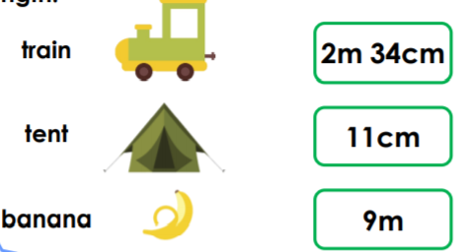
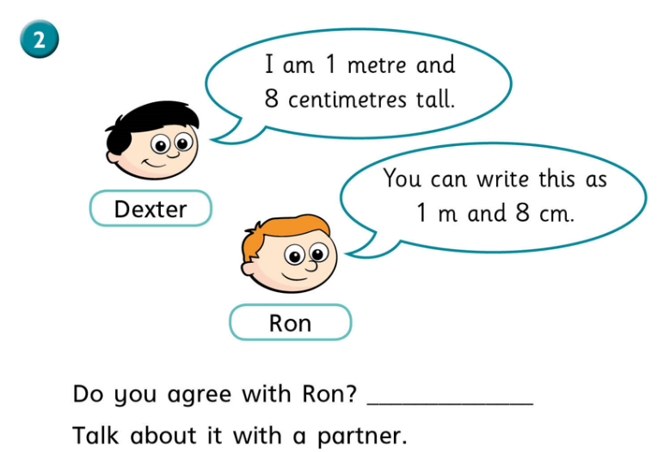
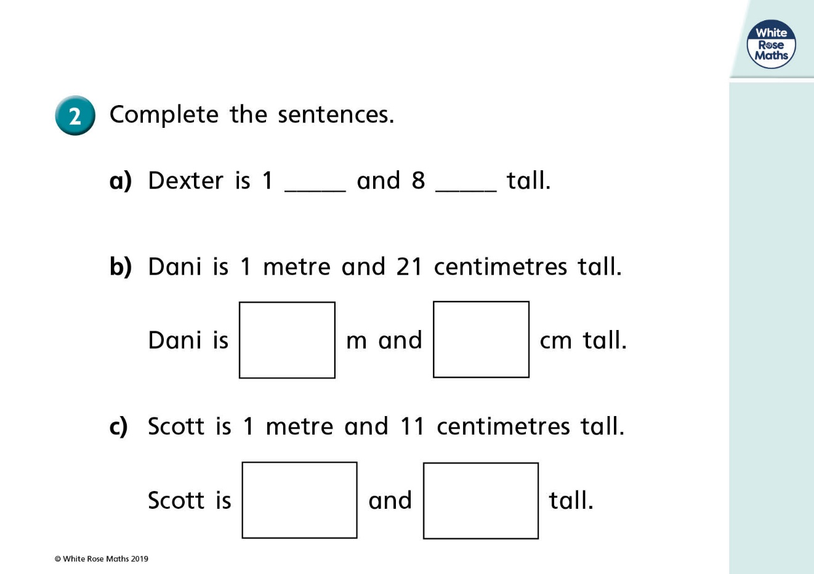
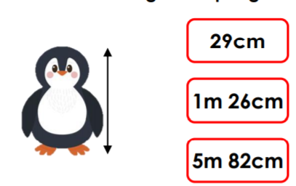
1)
2) Complete the sentences.
3) Circle the best estimate for the height of this penguin.
4) Match the item to the estimated length.

