Wednesday 7th October 2020

What is an adverbial?
https://www.bbc.co.uk/bitesize/topics/zwwp8mn/articles/zgsgxfr
What is an adverbial phrase?
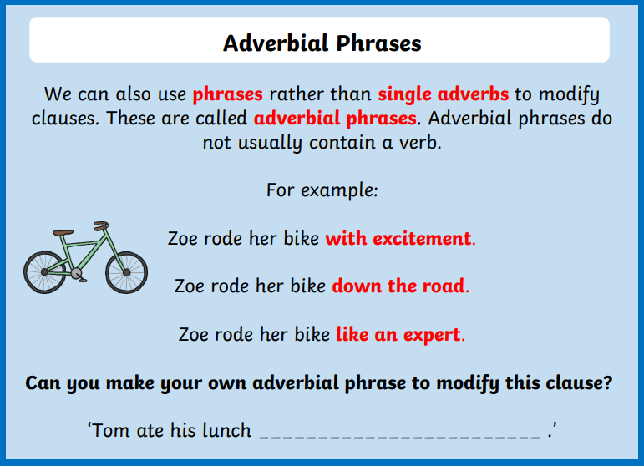
Can you go through your story map and add in some adverbials or adverbials phrases?

