Monday 5th October 2020

On Friday, you created your main character. Your task today is to story map the opening two sections of you Egyptian Adventure story. Remember a story map should look like this…
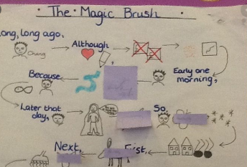
Remember the first two sections of the story are:


