
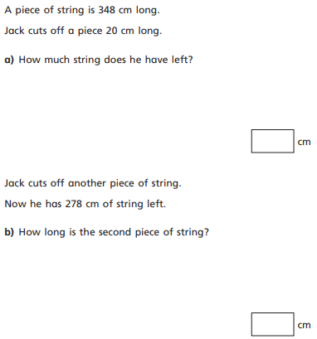
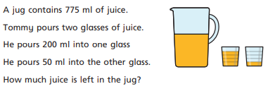
20.11.20
LO: To add and subtract
C: Mixed addition and subtraction problems

20.11.20
LO: To add and subtract
C: Mixed addition and subtraction problems

20.11.20
LO: To add and subtract
C: Mixed addition and subtraction problems

