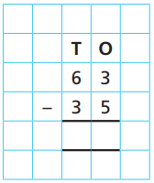
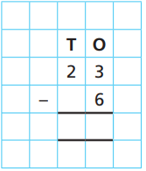
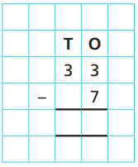
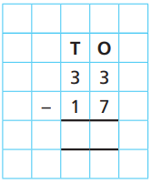

19.11.20
LO: To add and subtract
C: Subtract a 2-digit number from a 2-digit number - crossing 10
- subtract ones - subtract tens

Solve the following questions using the pictorial method.

In your books, write two questions of your own. One which requires an exchange and one which does not.

19.11.20
LO: To add and subtract
C: Subtract a 2-digit number from a 2-digit number - crossing 10
- subtract ones - subtract tens

Solve the following questions using the pictorial method.

In your books, write two questions of your own. One which requires an exchange and one which does not.

