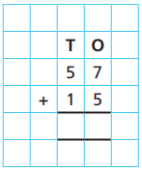
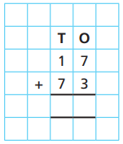
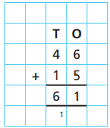

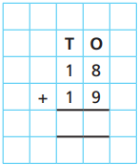
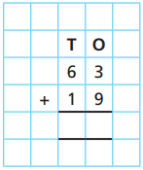
18.11.20
LO: To add and subtract
C: Add two 2-digit numbers - crossing 10 - add ones + add tens

Solve the following questions using place value counters alongside the formal method.

Look at the question 46 + 15 = 61. What does the little one (circled) represent?
__________________________________________________________________
__________________________________________________________________
_________________________________________________________________

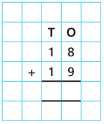

18.11.20
LO: To add and subtract
C: Add two 2-digit numbers - crossing 10 - add ones + add tens

Solve the following questions using place value counters alongside the formal method.

Look at the question 46 + 15 = 61. What does the little one (circled) represent?
__________________________________________________________________
__________________________________________________________________
_________________________________________________________________

