
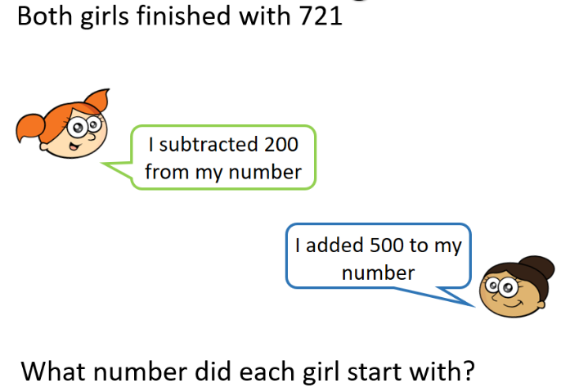
12.11.20
LO: To add and subtract
C: Add and subtract 100s.

Today, we started the lesson by completing the Century Tech nugget all about adding and subtracting 100.
Then we applied our knowledge to the following questions:

Complete each box for 728 + 200
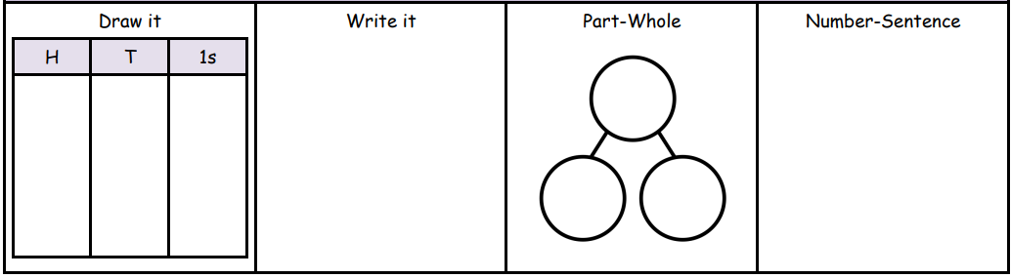

Solve the following question. Ensure you explain how you got your answer using pictures and words.

\\\
\\\\\\

