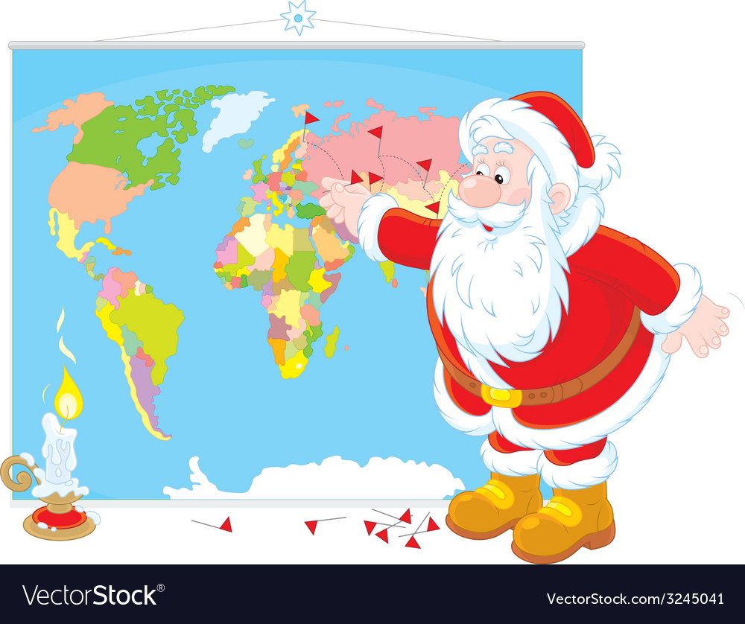
I wonder what the exact answer to each of these questions is?
4) Santa has delivered 482 presents to Binfield School Children and 64 to Binfield Staff. How many presents has he delivered to school?
3) Santa goes to 825 houses across Bracknell. He gets a cookie at 769 houses. Roughly, how many houses did not leave him a cookie?
2) In Bracknell there are 926 children. Santa has delivered 392 presents. Roughly how many presents does Santa have left to deliver?
- There are 754 Binfield’s children on Santa’s ‘Nice List’ and 112 on his ‘Naughty List’. Roughly, how many children are in Binfield altogether?
Wednesday 16th December 2020
LO: To add and subtract
C: To estimate answers

