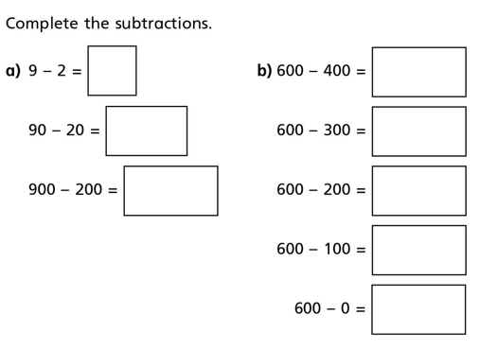
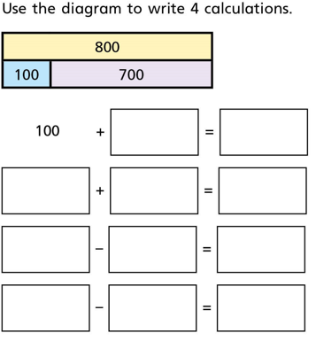
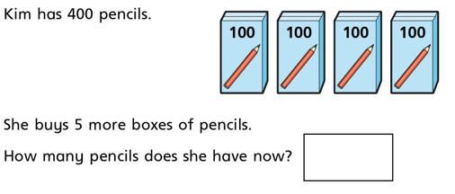
4)
In your book, can you draw a bar model to show 100 + 300 = 400
3)
2)

12.10.2020 L.O: Add and Subtract C: Add and subtract multiples of 100

1)

