
25.11.20
LO: To add and subtract
C: Add 2-digit and 3-digit numbers -crossing 10 or 100]

Now, try these in your books ensuring that:
- You only have 1 digit in each square
- You have put the correct digit in the correct place value column
- You have used a ruler to draw lines

- 845 + 72 = 2) 416 + 85 = 3) 386 + 34 =

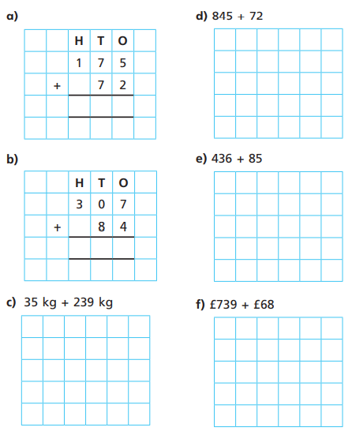

25.11.20
LO: To add and subtract
C: Add 2-digit and 3-digit numbers -crossing 10 or 100]

Now, try these in your books ensuring that:
- You only have 1 digit in each square
- You have put the correct digit in the correct place value column
- You have used a ruler to draw lines

- 845 + 72 = 2) 416 + 85 = 3) 386 + 34 =

