
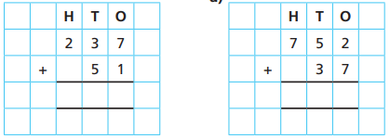
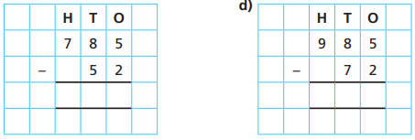
24.11.20
LO: To add and subtract
C: Add and subtract 2-digit and 3-digit numbers - not crossing 10 or 100]

Today we used Century Tech to learn how to add using the formal method. Then, we applied our new skills to the questions below.

