
12.11.20
LO: To add and subtract
C: Add and subtract 100s.

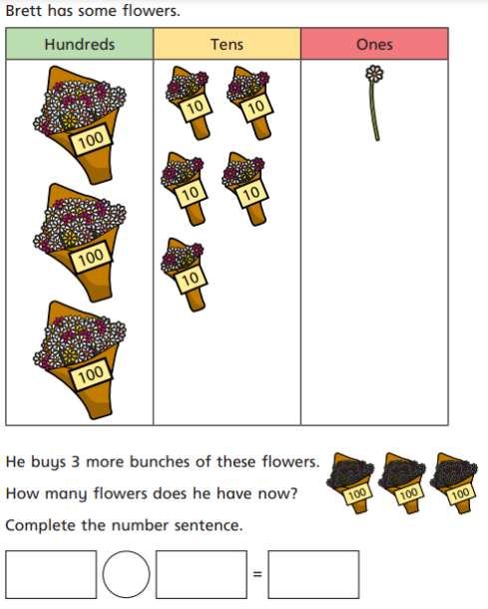
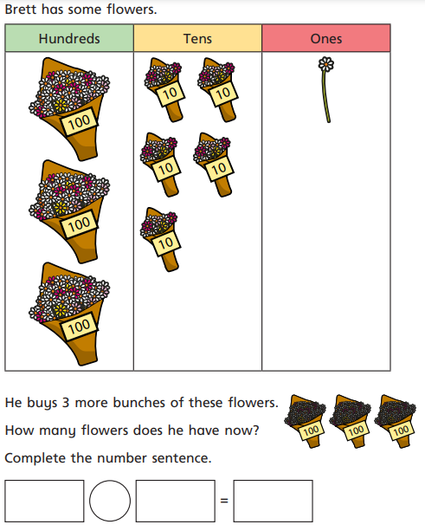
Brett has some flowers.

He buys three more bunches of flowers.

How many flowers does he have now?
Complete the number sentence.
Sam has some sweets.

By the end of the month he and his friends have eaten 200.

How many sweets does he have now?
Complete the number sentence.



1
10
10
100
1
1
1
1
10
10
100
1
100

Draw the pictures to go with the question below and solve it.
Mrs Rance has 432 pencils.

She buys 300 more packs.

How many pencils does she have now?
Complete the number sentence.
Make up a question of your own.
__________________________________________________________________________________

_________________________________________

How many ___________________________?
Complete the number sentence.

