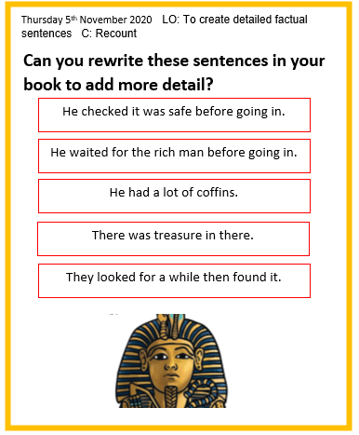
Thursday 5th November 2020 LO: To create detailed factual sentences C: Recount

He had a lot of coffins.
He waited for the rich man before going in.
He checked it was safe before going in.


They looked for a while then found it.
There was treasure in there.
Can you rewrite these sentences in your book to add more detail?

