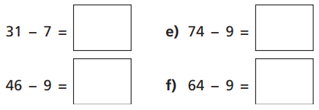
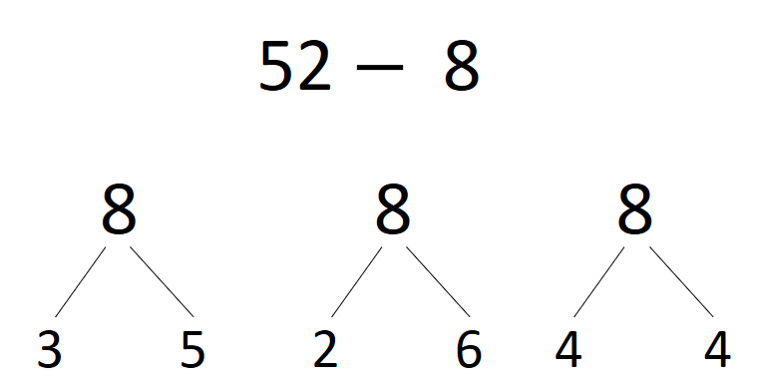
04.11.20
LO: To add and subtract
C: Subtract a 1 digit number from a 2 digit number - crossing 10 recap

- Draw a number line in your books showing the jumps you would take to solve the following? estions.
2) Which of these ways to partition 8 would be the most useful for this calculation? Why?
04.11.20
LO: To add and subtract
C: Subtract a 1 digit number from a 2 digit number - crossing 10 recap

- Draw a number line in your books showing the jumps you would take to solve the following? estions.
2) Which of these ways to partition 8 would be the most useful for this calculation? Why?

