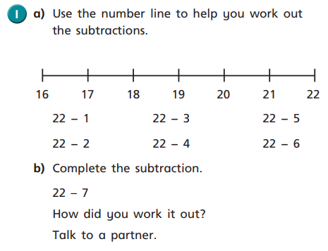
Using the number line below, solve 42 - 4.
What will your start number be? How will you solve this question?
04.11.20
LO: To add and subtract
C: Subtract a 1 digit number from a 2 digit number –crossing 10 recap

Using the number line to help you work out the subtractions.
Using the number line below, solve 42 - 4.
What will your start number be? How will you solve this question?
04.11.20
LO: To add and subtract
C: Subtract a 1 digit number from a 2 digit number –crossing 10 recap

Using the number line to help you work out the subtractions.

