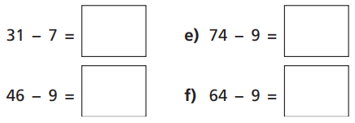
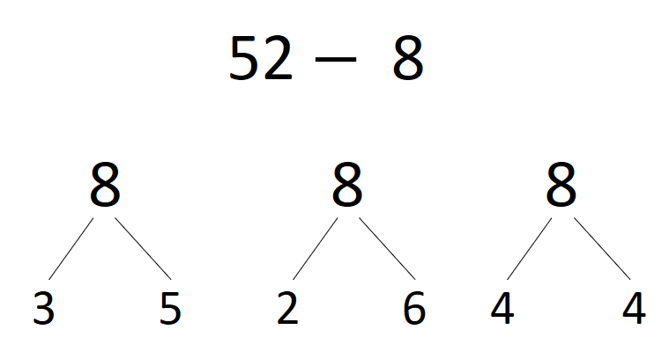
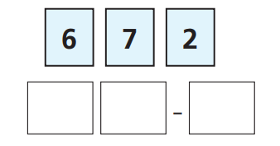
04.11.20
LO: To add and subtract
C: Subtract a 1 digit number from a 2 digit number - crossing 10 recap
- Draw a number line in your books showing the jumps you would take to solve the following:
2) Which of these ways to partition 8 would be the most useful for this calculation? Why?

- Use the three digit cards to write a subtraction.
- How many different answers can you find?

3) Use the three digit cards to write a subtraction.
- How many different answers can you find?

04.11.20
LO: To add and subtract
C: Subtract a 1 digit number from a 2 digit number - crossing 10 recap
- Draw a number line in your books showing the jumps you would take to solve the following:
2) Which of these ways to partition 8 would be the most useful for this calculation? Why?

- Use the three digit cards to write a subtraction.
- How many different answers can you find?

3) Use the three digit cards to write a subtraction.
- How many different answers can you find?

