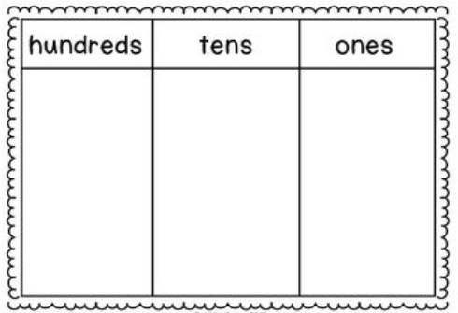
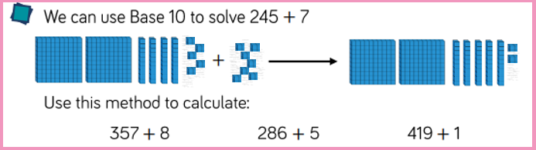
3.11.20
LO: To add and subtract
C: To add a 3-digit number to a 1-digit number - crossing 10
Represent the following questions pictorially.
134 + 8 = 214 + 6 =

3.11.20
LO: To add and subtract
C: To add a 3-digit number to a 1-digit number - crossing 10
Represent the following questions pictorially.
134 + 8 = 214 + 6 =

