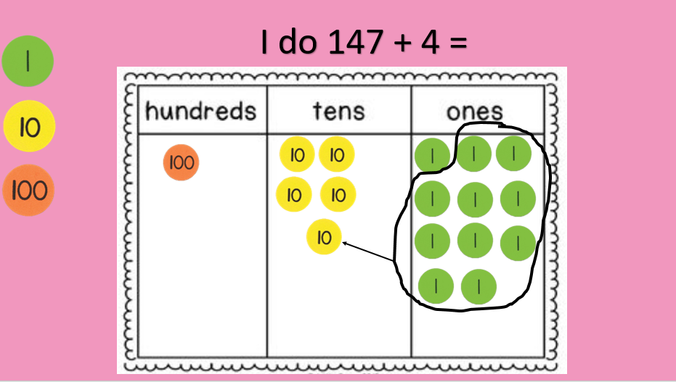
Miss George has worked out 147 + 4 using place value counters. She got the answer 151. However, Mrs Mistry missed the lesson and does not understand this method. Can you explain it to her?
Miss George has worked out 147 + 4 using place value counters. She got the answer 151. However, Mrs Mistry missed the lesson and does not understand this method. Can you explain it to her?

