
11.11.20
LO: To add and subtract
C: Spotting patterns - making it explicit

Red pen question:
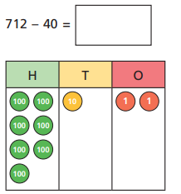
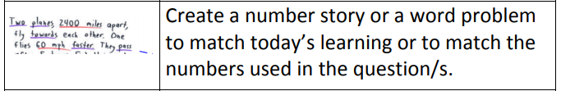
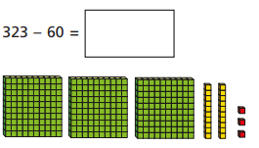
11.11.20
LO: To add and subtract
C: Subtract 3-digit numbers and 2-digit numbers - crossing 100

Using the pictorial representations to help you. Solve the following questions:

Red pen question:

