
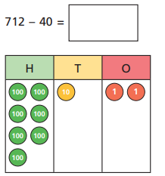
11.11.20
LO: To add and subtract
C: Subtract 3-digit numbers and 2-digit numbers - crossing 100

Solve the following questions using place value counters. Right your answer on the sheet.
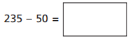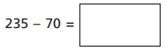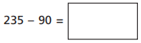
Red pend question: Using the pictorial representation which has been started for you, can you solve the question below?

11.11.20
LO: To add and subtract
C: Subtract 3-digit numbers and 2-digit numbers - crossing 100

Solve the following questions using place value counters. Right your answer on the sheet.
Red pend question: Using the pictorial representation which has been started for you, can you solve the question below?

