
10.11.20
LO: To add and subtract
C: Add 3-digit numbers and 2-digit numbers - crossing 100

Solve the following questions by drawing place value counters:
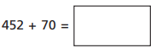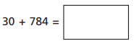
For these questions, represent the question using the bar model:
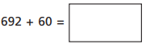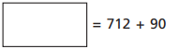

Red pen question: Which method did find the most effective for the questions above? Why?
Use the sentence start below to help you start your answer.

I sound using place value counters/bar model (circle the method you chose) the most effective for answering the questions because…
10.11.20
LO: To add and subtract
C: Add 3-digit numbers and 2-digit numbers - crossing 100

Solve the following questions by drawing place value counters:
For these questions, represent the question using the bar model:

Red pen question: Which method did find the most effective for the questions above? Why?
Use the sentence start below to help you start your answer.

I sound using place value counters/bar model (circle the method you chose) the most effective for answering the questions because…

