
10.11.20
LO: To add and subtract
C: Add 3-digit numbers and 2-digit numbers - crossing 100
Solve the following questions pictorially in your books or by using resources.
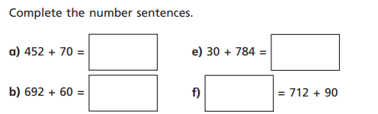

Red pen question: Which method did you use to solve the questions above? Why?
Use the sentence start below to help you start your answer.

I chose to solve the questions above pictorially/using resources (circle the method you chose) because
10.11.20
LO: To add and subtract
C: Add 3-digit numbers and 2-digit numbers - crossing 100

Solve the following questions pictorially in your books or by using resources.

Red pen question: Which method did you use to solve the questions above? Why?
Use the sentence start below to help you start your answer.

I chose to solve the questions above pictorially/using resources (circle the method you chose) because

