
10.11.20
LO: To add and subtract
C:Add 3-digit numbers and 2-digit numbers -crossing 100

Solve the following questions using place value counters. Right your answer on the sheet.
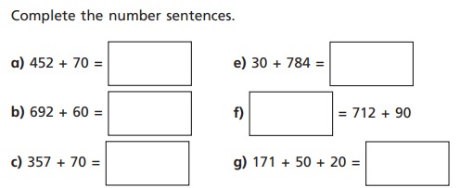
Red pen question: Why are place value counters useful when solving these questions?
Use the sentence starter below to help you.
I found place value questions useful for solving these questions because …
10.11.20
LO: To add and subtract
C:Add 3-digit numbers and 2-digit numbers -crossing 100

Solve the following questions using place value counters. Right your answer on the sheet.
Red pen question: Why are place value counters useful when solving these questions?
Use the sentence starter below to help you.
I found place value questions useful for solving these questions because …

