Monday 13th September 2020 L.O: To know and use numbers. C: Place Value
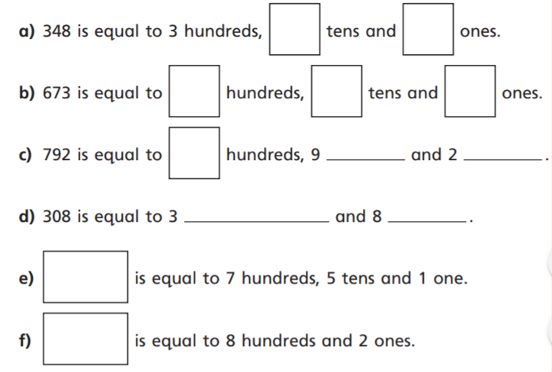
1)

2) Fill in the gaps and partition the numbers
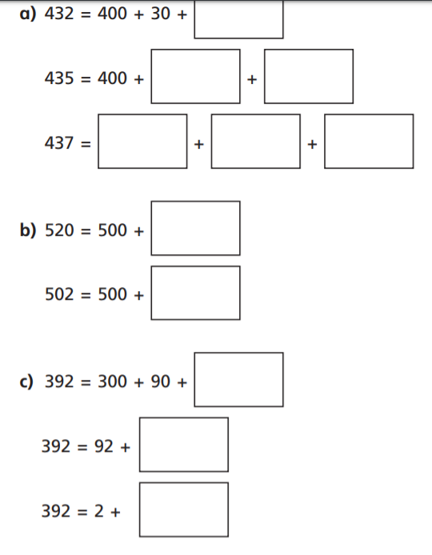

3)



