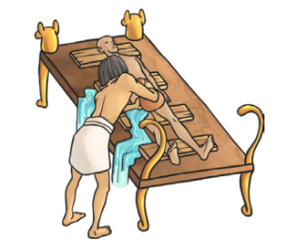
Monday 7th December
L.O: To apply prepositions of place.
C: Explanation Text

- Can you fill in the blanks in these sentences?

Insert a hook ………………….. the nose to break up and remove the brains.

Once the internal organs are removed, place them ……………………….. the appropriate canopic jars.

Place the mummified body, ….. the sarcophagus.

- In your book. Can you write a sentence including a preposition? Use this picture to help you.

Monday 7th December
L.O: To apply prepositions of place.
C: Explanation Text

- Can you fill in the blanks in these sentences?

Insert a hook ………………….. the nose to break up and remove the brains.

Once the internal organs are removed, place them ……………………….. the appropriate canopic jars.

Place the mummified body, ….. the sarcophagus.

- In your book. Can you write a sentence including a preposition? Use this picture to help you.

