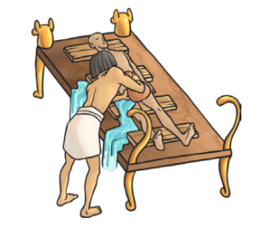
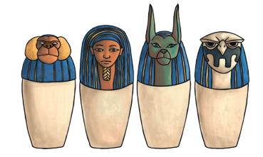
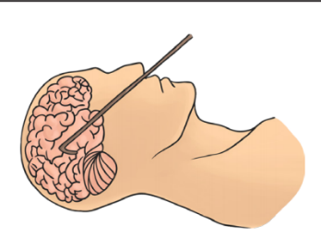
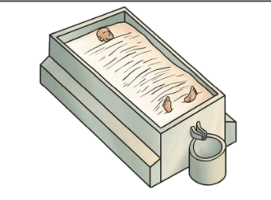
Monday 7th December
L.O: To apply prepositions of place.
C: Explanation Text

- In your book. Can you write sentences including a preposition? Use the pictures to help you. Make sure you highlight your prepositions!

Monday 7th December
L.O: To apply prepositions of place.
C: Explanation Text

- In your book. Can you write sentences including a preposition? Use the pictures to help you. Make sure you highlight your prepositions!

