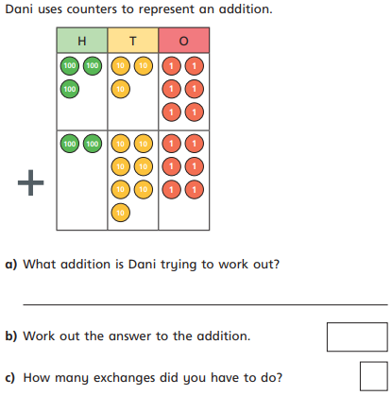
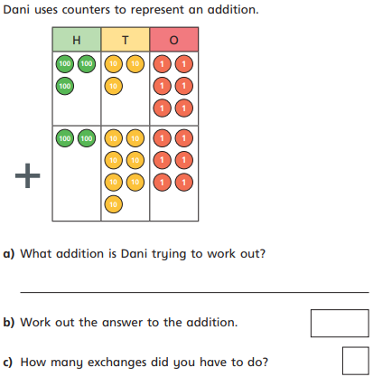

11.12.20
LO: To add and subtract
C: Add two 3-digit numbers - crossing 10 or 100

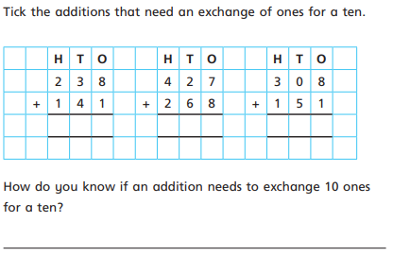


Now use the formal method to solve the following:
- 187 + 471 = b) 718 + 108 = c) 526 + 294 =

