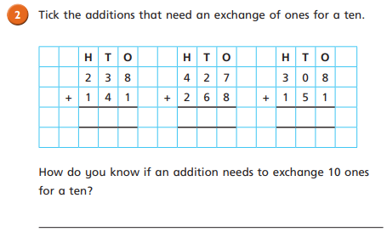
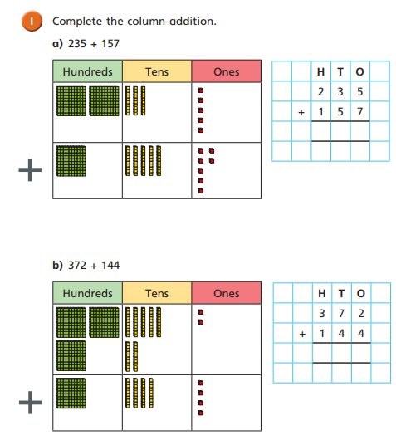

11.12.20
LO: To add and subtract
C: Add two 3-digit numbers - crossing 10 or 100
11.12.20
LO: To add and subtract
C: Add two 3-digit numbers - crossing 10 or 100

