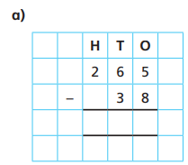
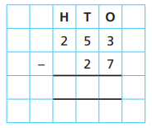
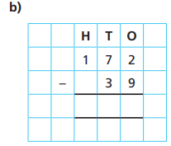
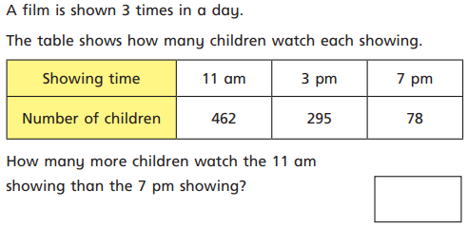

08.12.20
LO: To add and subtract
C: Subtract a 2-digit number from a 3-digit numbers - crossing 10 or 100

Now, in your books try:
1) 212 - 42 = 2) 538 - 75 = 3) 847 - 79 =
4)

08.12.20
LO: To add and subtract
C: Subtract a 2-digit number from a 3-digit numbers - crossing 10 or 100

Now, in your books try:

1) 212 - 42 = 2) 538 - 75 = 3) 847 - 79 =

4)

