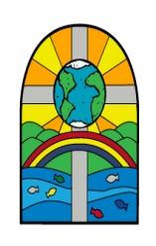

 | LEARNING OBJECTIVE  Context | Milestone Indicator(s) | Key teaching points and organisation of learners including use of adults | How will children access the LO?  What does success look like? | Next steps
1 | LO: To explore an image  C: Growing up |  | Show the children the following picture with the boys answer hidden:  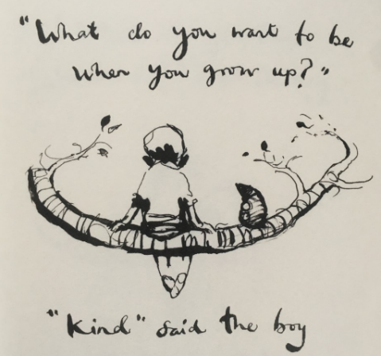  What do you think the boy and the mole are doing?  Where do you think they are?  What do you think the answer will be?  Who do you think is asking the question?  Reveal the boys answer.  Does this answer surprise you? Why/why not?  Why do you think he gave this answer?  Children to note their initial thoughts to the picture around the edge  Task 1  Bring the children back together and discuss what answer they would give if they were asked the question by the mole?  (a good friend, loyal, caring)  Discuss the reasons for their answer | Task 1  Children to annotate the picture with their thoughts  Task 2  Children to draw themselves next to the mole. They need to write the question above and their own answer below.
2 | LO: To explore an image  C: Be kind to yourself |  | Look at the picture below:  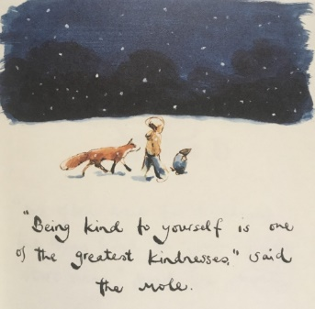  What do you think the quote means?  What does being kind to yourself mean?  How can we be kind to ourselves?  What sorts of things can we do?  Have a discussion and note down the children’s thoughts about what they think being kind to yourself means.  Tell the children that they need to explain what ‘being kind to yourself’ means. Can they put this into their own words underneath the picture? | Children to write their own definition of what being kind to yourself means under the picture.  Ext: Write down 5 ways you can look after yourself.

