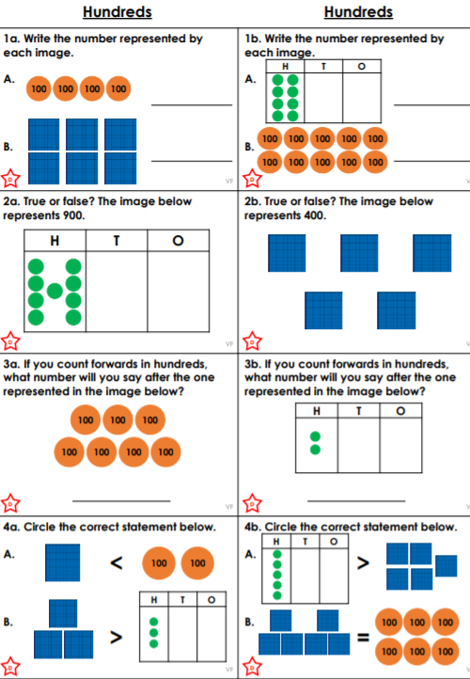
9.9.2020
L.O: To understand place value in 3 digit numbers.
C: Place Value

