7.9.2020
L.O: To know and use numbers.
C: Number 5

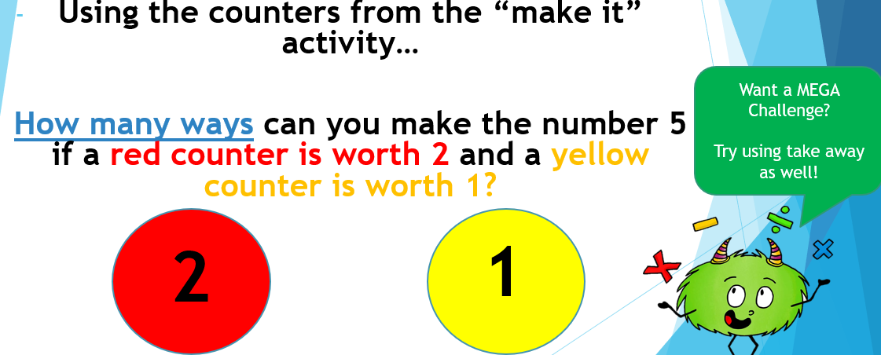
Number 5 in the real world!

